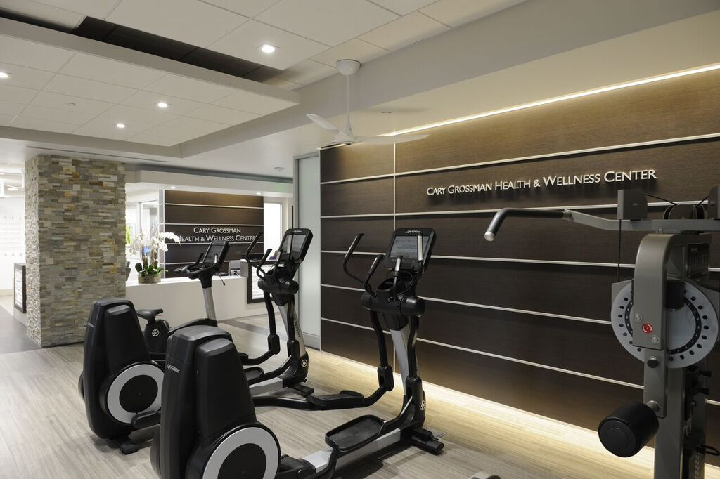
*Registration is required to participate in all classes. Call to register for classes.
TUESDAY
WEDNESDAY
THURSDAY
MONDAY
FRIDAY

*2:30 to 4:00 pm
Cardiac Wellness Class
Registration Required

*2:30 to 4:00 pm
Cardiac Wellness Class
Registration Required

*11:00 to 11:50 am
Chair Yoga
Punch Card Only
Registration Required

4:30 to 5 pm
HIIT

*5:00 to 5:50 pm
Yoga
Punch Card Only

*11:00 to 11:50 am
Chair Yoga
Punch Card Only
Registration Required

4:30 to 5:00 pm
HIIT

*2:30 to 4:00 pm
Cardiac Wellness Class
Registration Required

